SCRUTINY: BY YP, FOR YP*
Hertfordshire County Council
Scrutiny
In 2017 we were looking for ways of engaging with audiences outside of our interest group.  Simultaneously Children’s Services were trying to find ways to further capture the voice of young people (YP) in care.  We realized that combining these issues would make the voice of YP in care heard and share the benefit of scrutiny and the impact it can have, to a wider audience.  To achieve this we decided to hold a task and finish group, replacing Councillors with YP from the Children in Care Council (CHICC).  The first challenge was to condense all the topics CHICC members wanted to scrutinize. Eventually we focused on how the service manages children in care returning to birth families.  We worked with officers to agree that they would commit to action the resulting recommendations.  The CHICC appointed their own YP Chair and we briefed them and supported the development of key lines of enquiry as we would with Councillors.  Throughout the day YP challenged officers on current practice and brought areas of concern to the attention of those present.  The recommendations were put to officers with a deadline for response as with legislation for regular scrutiny.  The outcomes were reported to Overview Scrutiny Committee.  Feedback from the CHICC was positive of how they had been able to influence future work.  We succeeded in increasing awareness of scrutiny and hearing the voice of YP. |  | **

…the Children In Care Council could see how they had influenced future working practices…

**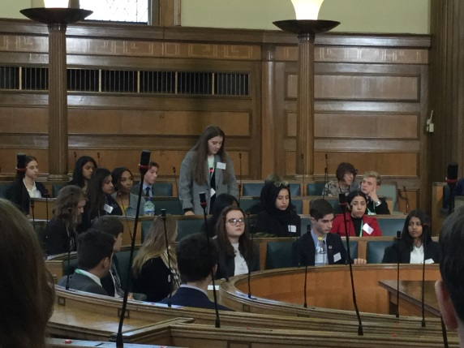

*YP – Young People ** stock photos have been used because of child protection laws.

